Week 1 Assignment: Python Fundamentals for Data Analytics
Name : Sulthan Vaishnavi
College: IARE
Branch: DataScience

Task 1: Python Basics
Objective: Display a welcome message and accept personal and academic details.
Code:
print("Welcome to Python Fundamentals for Data Analytics!")
name = input("Enter your name: ")
college = input("Enter your college name: ")
branch = input("Enter your branch: ")
print("\n----- Student Information -----")
print("Name:", name)
print("College:", college)
print("Branch:", branch)
Explaination:
print() displays information, while input() accepts information entered by the user. The \n creates a new line.
Output:

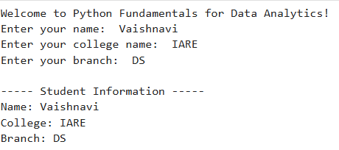
Task 2: Variables and Data Types
Objective: Declare four different data types and display their types using type().
age = 20
percentage = 85.5
name = "Vaishnavi"
is_student = True

print("Age:", age, "| Type:", type(age))
print("Percentage:", percentage, "| Type:", type(percentage))
print("Name:", name, "| Type:", type(name))
print("Is Student:", is_student, "| Type:", type(is_student))
Explaination:
• int: Whole numbers.
• float: Decimal numbers.
• str: Text.
• bool: True or False values.
Output:

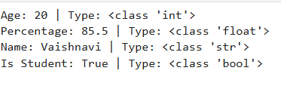

Task 3: Operators
Objective: Build a calculator that performs five arithmetic operations on two user-entered numbers.
Code:
a = float(input("Enter the first number: "))
b = float(input("Enter the second number: "))

print("Addition:", a + b)
print("Subtraction:", a - b)
print("Multiplication:", a * b)

if b != 0:
print("Division:", a / b)
print("Modulus:", a % b)
else:
print("Division and modulus are not possible with zero.")
Explaination:
The operators +, -, *, /, and % perform addition, subtraction, multiplication, division, and modulus. The if statement prevents division by zero.

Output:
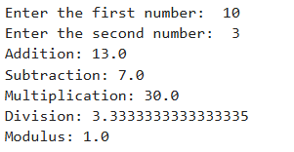
Task 4: Conditional Statements
Objective : Assign a grade based on marks using if, elif, and else.
Code:

marks = float(input("Enter your marks (0-100): "))
if marks < 0 or marks > 100:
print("Invalid marks")
elif marks >= 90:
print("Grade: A")
elif marks >= 75:
print("Grade: B")
elif marks >= 60:
print("Grade: C")
else:
print("Grade: Fail")
Explaination:
Conditional statements execute different blocks of code depending on the entered marks. The program also checks whether marks are within the valid range of 0–100.

Output:
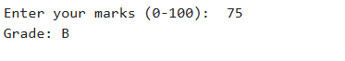

Task 5 : Loops
Objective: Use for and while loops to print number sequences and multiplication tables.
Program 1:
for i in range(1, 21):
print(i, end=" ")
Output:

Program 2:
number = int(input("Enter a number: "))
for i in range(1, 11):
print(number, "x", i, "=", number * i)
Output:
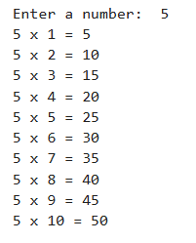
Program 3:
i = 2
while i <= 50:
print(i, end=" ")
i += 2

Output:
Explaination:
A for loop iterates over a sequence, while a while loop repeats as long as its condition is true. range(1, 21) generates numbers from 1 through 20.

Task 6: Functions
Objective:
Create functions to calculate the square of a number and the average of three numbers.
Code:
def square(number):
return number * number
def average(a, b, c):
return (a + b + c) / 3
n = float(input("Enter a number to find its square: "))
print("Square:", square(n))
x = float(input("Enter the first number: "))
y = float(input("Enter the second number: "))
z = float(input("Enter the third number: "))
print("Average:", average(x, y, z))
Explaination:
The def keyword defines a function. The return statement sends the calculated result back to the calling code.
Output:
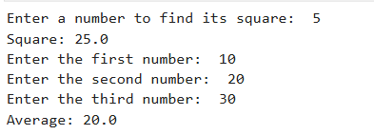

Task 7: Strings and Collections
Objective: Demonstrate string methods and the operations supported by lists, tuples, dictionaries, and sets.
Code:
# 1. String operations
text = "Python Programming"
print("Original:", text)
print("Uppercase:", text.upper())
print("Lowercase:", text.lower())
print("Replace:", text.replace("Python", "Data"))
print("Position of Programming:", text.find("Programming"))
# 2. List operations
numbers = [40, 10, 30, 20]
numbers.append(50)
print("\nAfter append:", numbers)
numbers.remove(10)
print("After remove:", numbers)
numbers.sort()
print("After sort:", numbers)

# 3. Tuple creation and indexing
fruits = ("Apple", "Banana", "Mango")
print("\nTuple:", fruits)
print("First fruit:", fruits[0])
print("Third fruit:", fruits[2])
# 4. Dictionary storing student information
student = {
"name": "Vaishnavi",
"branch": "CSE",
"marks": 85
}
print("\nStudent Information:", student)
print("Student Name:", student["name"])
print("Student Branch:", student["branch"])
# 5. Set operations
colors = {"Red", "Blue", "Green"}
colors.add("Yellow")
print("\nAfter add:", colors)
colors.remove("Blue")
print("After remove:", colors)

Explaination:
Collection or Method | Purpose
upper() | Converts text to uppercase.
lower() | Converts text to lowercase.
replace() | Replaces part of a string with another string.
find() | Returns the index of a substring.
append() | Adds an item to a list.
remove() | Removes a matching item from a list or set.
sort() | Sorts list elements in ascending order by default.
Tuple | Stores ordered items in an immutable collection.
Dictionary | Stores data in key-value pairs.
Set | Stores unique elements without maintaining a guaranteed order.

Output:
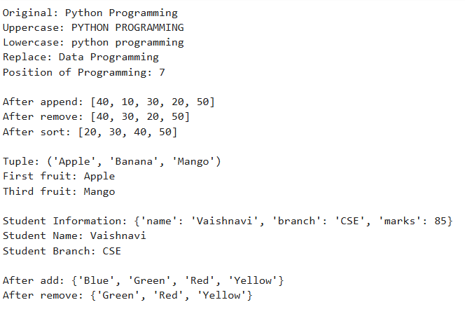

Task 8: Basic File Handling
Objective: Create a text file, write an introduction into it, and read and display its contents.
Code:
name = input("Enter your name: ")
college = input("Enter your college name: ")
branch = input("Enter your branch: ")

# Write information into a text file
with open("introduction.txt", "w") as file:
file.write("Student Introduction\n")
file.write("Name: " + name + "\n")
file.write("College: " + college + "\n")
file.write("Branch: " + branch + "\n")

print("Introduction saved successfully.")

# Read and display the file contents
with open("introduction.txt", "r") as file:
content = file.read()

print("\nFile Contents:")
print(content)

Explaination:
• open() opens or creates a file.
• "w" opens a file for writing and overwrites existing contents.
• "r" opens a file for reading.
• write() writes text to the file.
• read() reads the file contents.
• with automatically closes the file when the block finishes.
Output:
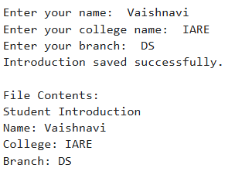
Task 9: Mini Project — Student Record Management System
Objective: Develop a menu-driven application that adds, displays, searches, and deletes student records using a list of dictionaries.
Code:
students = []
def add_student():
name = input("Enter student name: ").strip()
roll_no = input("Enter roll number: ").strip()
branch = input("Enter branch: ").strip()
if not name or not roll_no or not branch:
print("All fields are required.")
return
if any(s["roll_no"].lower() == roll_no.lower()
for s in students):
print("Roll number already exists.")
return

student = {
"name": name,
"roll_no": roll_no,
"branch": branch
}
students.append(student)
print("Student added successfully.")
def display_students():
if not students:
print("No student records available.")
return
print("\n--- All Student Records ---")
for student in students:
print("Name:", student["name"])
print("Roll Number:", student["roll_no"])
print("Branch:", student["branch"])
print("-------------------------")
def search_student():
name = input("Enter student name to search: ").strip()
found = False
for student in students:
if student["name"].lower() == name.lower():
print("Student Found:")
print("Name:", student["name"])
print("Roll Number:", student["roll_no"])
print("Branch:", student["branch"])
found = True

if not found:
print("Student not found.")
def delete_student():
roll_no = input("Enter roll number to delete: ").strip()
for student in students:
if student["roll_no"].lower() == roll_no.lower():
students.remove(student)
print("Student deleted successfully.")
return
print("Student not found.")
while True:
print("\n===== Student Record Management =====")
print("1. Add Student")
print("2. Display All Students")
print("3. Search Student by Name")
print("4. Delete Student")
print("5. Exit")
choice = input("Enter your choice (1-5): ").strip()
if choice == "1":
add_student()
elif choice == "2":
display_students()
elif choice == "3":
search_student()
elif choice == "4":
delete_student()
elif choice == "5":
print("Exiting Student Record Management System.")
break
else:
print("Invalid choice. Please try again.")
Explaination:
• Add Student: Accepts the name, roll number, and branch, then stores the record.
• Display All Students: Displays every stored record.
• Search Student: Searches by name without distinguishing uppercase and lowercase letters.
• Delete Student: Deletes the record using the roll number.
• Menu system: Repeats until the user selects Exit.
• Data storage: A list stores dictionaries, with each dictionary representing one student.
Output:
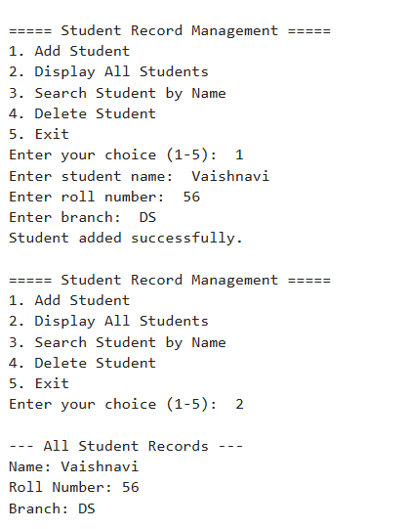
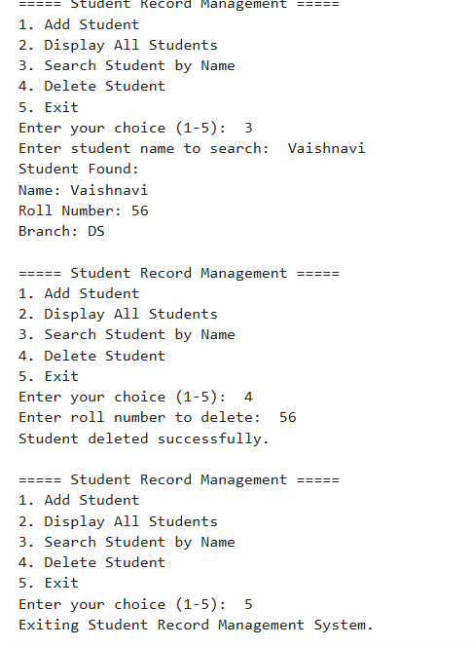
Conclusion:
Through this Week 1 assignment, I learned the fundamentals of Python programming, including variables, data types, operators, conditional statements, loops, functions, strings, and collections. I also practiced basic file handling and developed a Student Record Management System using lists, dictionaries, and user-defined functions. This assignment helped me understand how Python can be used to solve basic programming problems and build a foundation for data analytics.

